Your devotional is a single file that runs entirely on your computer. No internet, account or app store is needed.
- Download your purchase from Etsy and unzip it (right-click, then Extract All on Windows; double-click on Mac).
- Move the file 40-Days Devotional.html to a folder you will remember, such as Documents.
- Double-click the file. It opens in your web browser (Chrome, Edge, Safari or Firefox).
- Tip: right-click the file and choose Send to, Desktop (create shortcut) on Windows, or drag it to your Dock on Mac, so it is one click away each day.
Works on: Windows, Mac and Chromebook laptops and desktops. This devotional is designed for computers and works well on Android devices. This devotional not designed for iPhone or iPad.
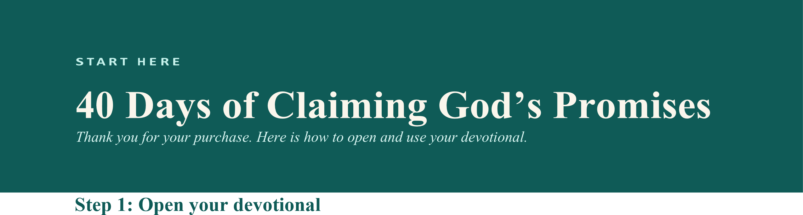
Important: always open the same file in the same browser so your progress and notes are there. Please do not move or rename the file after you start. Make a backup from Settings (see page 2).

Step 2: Begin
Tap Begin today’s devotional. Each day has Scripture (KJV), a message, a life application, reflection questions, a prayer and a declaration. Mark the day complete when you are done. Your progress, notes and gratitude entries are saved automatically.
JOURNAL AND NOTES FAVORITES AND SEARCH
Write notes on any day. Find them all under My Tap the heart to save a promise. Use the search icon Journal, sorted by date. You can search them too. to find a theme, a Scripture reference or a word.

40 Days of Claiming God’s Promises · Page 1 of 2

Make your own printable devotional book (PDF)
- Open the app, go to Settings and tap Export my 40-day devotional.
- Type your name if you would like it on the cover. Choose A4 or US Letter. Choose which days to include.
- Tick Include my journal notes and gratitude entries if you want them in the book. Tick the certificate option after you finish all 40 days.
- Tap Download PDF. Print it at home, or at a print shop for a bound copy.
Every day has a Read page and a Reflect page, and the Reflect page is ruled for handwritten notes.

Keeping your progress safe
Your progress and notes are saved in your browser on the device you use. Nothing is uploaded to anyone.
Because of this, clearing your browser data, or opening the app on a different device, will not show your earlier notes.
To keep a backup, open Settings and tap Export JSON. Keep that file somewhere safe. To restore it on this or another device, tap Import backup. (Settings also offers TXT, Markdown and CSV exports of your notes.)

Troubleshooting
The file opens as text or asks which app to use. Right-click the file, choose Open with, then pick Chrome, Edge, Safari or Firefox.
The page looks plain, or buttons do not work. Unzip the file first, then open it in Chrome, Edge, Safari or Firefox. Do not open it inside a zip preview or an email.
My download did not start. Allow downloads for the page when your browser asks, then try again.
Anything else. Message me on Etsy and I will help.

Terms of use
This is a digital product. No physical item is shipped. It is licensed for your personal use on your own devices and for printing your own copies. Scripture quotations are from the King James Version (public domain). Sales of digital items are final, but if something is wrong, please contact me and I will make it right.
40 Days of Claiming God’s Promises · Page 2 of 2

